Non-obvious controls:
- The zero position for Potential Energy is just below the “table top” where the masses sit. The draggable dotted line is just something handy.
- All the springs have the same characteristics by default. The stiffness of spring number three can be varied. Put the slider in the middle to reset.
- To reset the energy graph, take the mass off the spring. If it is hard to release a mass, slow it down by adjusting time or a slider.
- Most things on the screen are draggable: the ruler, the dotted line, and masses.
- There is a zoom feature for all Flash simulations. Right click on the sim and select Zoom in. This can be helpful when you are using a projector or writing a lesson where you want a screen shot.
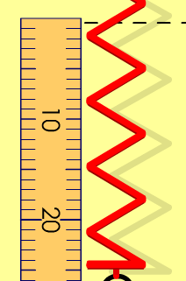
- The horizontal dotted line and ruler are movable to be helpful for relative reference. The bottom of the spring will provide numbers that are easy to make relationships.

Important modeling notes / simplifications:
- Keep the masses in the window for thorough energy analysis because the PE for the graph is calculated as an absolute value.
- The KE will not be calculated if you are moving the cylinder with the mouse
- The acceleration due to gravity for earth is set at 9.8 m/s²

Insights into student use / thinking:
- You may want the students to start with “No Friction”
- For precise measuring, use Zoom In (by right clicking).

Suggestions for sim use:
- For tips on using PhET sims with your students see: Guidelines for Inquiry Contributions and Using PhET Sims
- The simulations have been used successfully with homework, lectures, in-class activities, or lab activities. Use them for introduction to concepts, learning new concepts, reinforcement of concepts, as visual aids for interactive demonstrations, or with in-class clicker questions. To read more, see Teaching Physics using PhET Simulations
- For activities and lesson plans written by the PhET team and other teachers, see: Teacher Ideas & Activities

